### 

### **1. Why Plugins Matter in Real-World Testing**

JMeter on its own is powerful, but plugins bring **enterprise-level features** for:

* Simulating **complex load patterns**
* Visualizing **key performance indicators (KPIs)**
* Extending **protocol support** (e.g., Kafka, MQTT, WebSockets)
* Enhancing **data extraction**, **logic control**, and **debugging**

### **🛠️ 2. Hands-On Use Cases by Plugin Category**

#### **📊 A. Custom Thread Groups (Highly recommended for load testing at scale)**

| **Plugin** | **Use Case** | **Benefit** |
| --- | --- | --- |
| **Ultimate Thread Group** | Simulate high concurrency for spike testing | Custom ramp-up, hold, ramp-down phases |
| **Concurrency Thread Group** | Maintain fixed concurrent users for SLA validation | Useful in stability tests |
| **Stepping Thread Group** | Gradually increase/decrease users | Ideal for identifying breaking points |

🔁 These plugins allow far more control compared to the default **Thread Group**, especially for **performance and stress testing**.

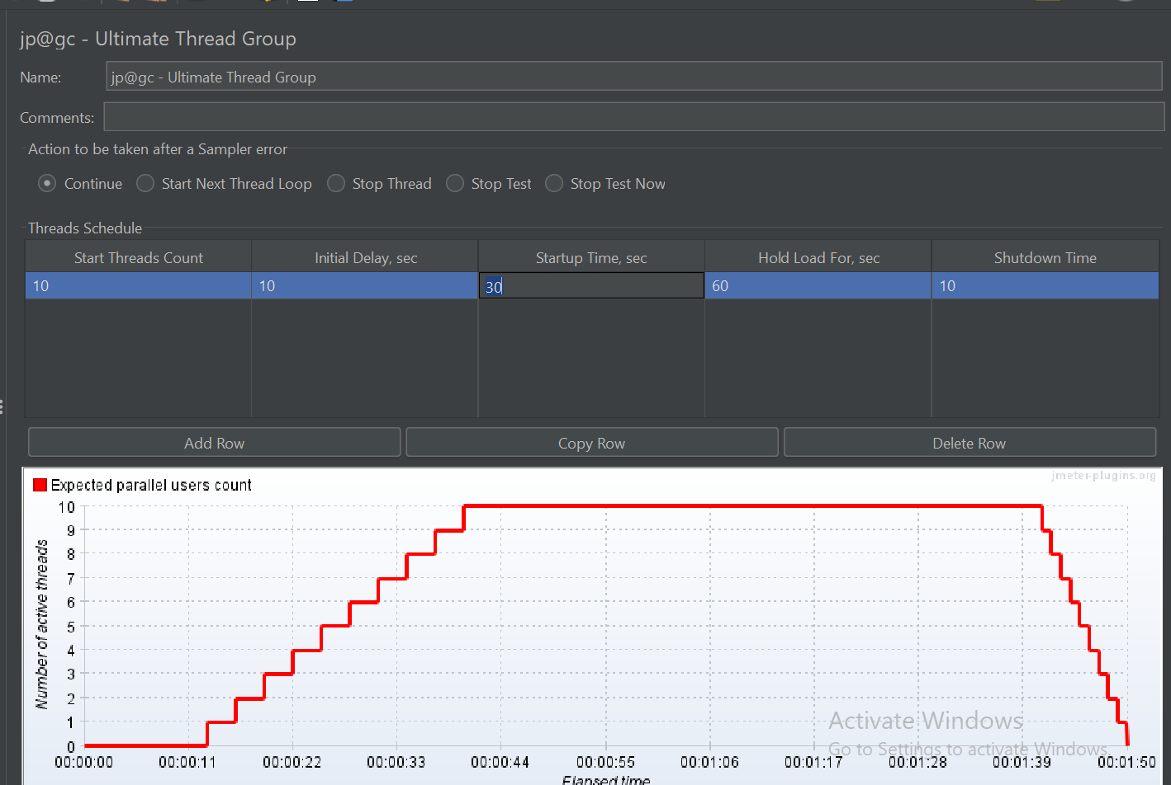

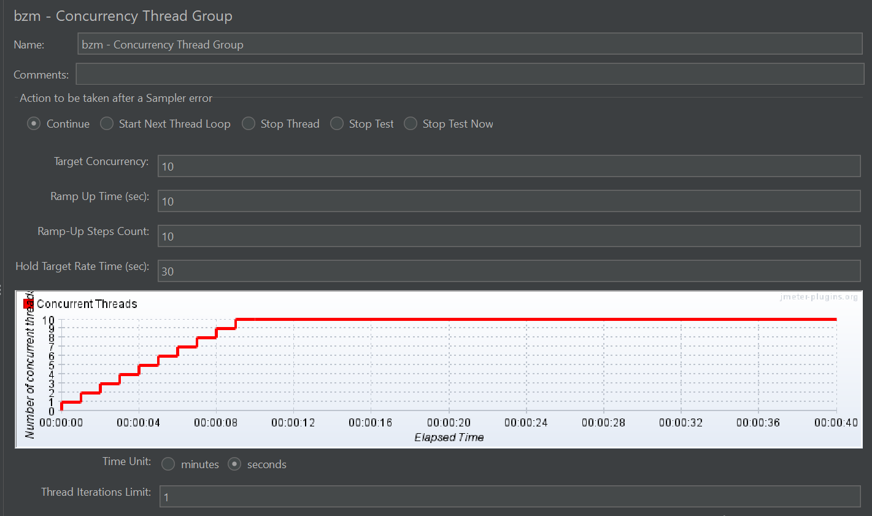

#### **📉 B. Advanced Listeners**

* **Active Threads Over Time** → See live thread distribution
* **Response Times Over Time** → Spot slow periods
* **Transaction Per Second** → Monitor server throughput
* **Bytes Throughput Over Time** → Check network usage
* **Composite Graph** → Overlay multiple KPIs in one view
* **Flexible File Writer** → Write custom logs for external dashboards

🎯 *These plugins are essential for real-time analysis and comparing multiple performance metrics together.*

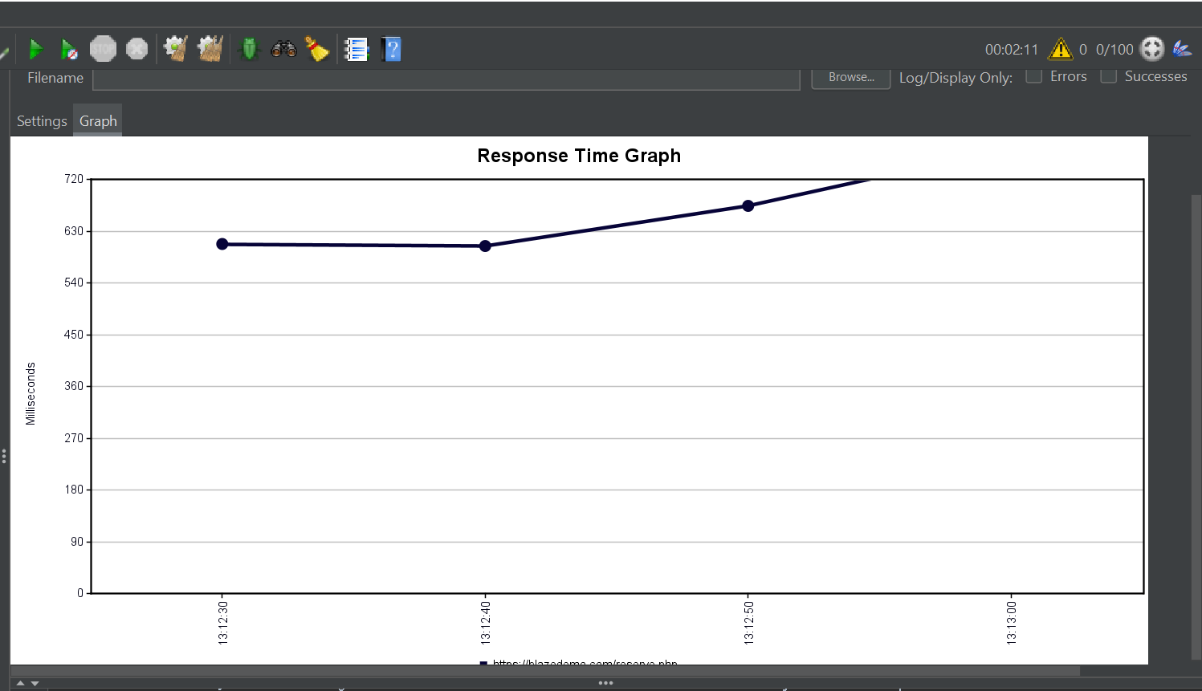

#### **⏱️ C. Precise Load Injection with Timers**

| **Plugin** | **Purpose** |
| --- | --- |
| **Throughput Shaping Timer** | Define target RPS (e.g., 100 RPS for 5 minutes) |
| **Constant Throughput Timer** (core) | Maintains fixed throughput rate |
| **Random Timer** | Add think time variability |

📌 Use **Throughput Shaping Timer** + **Concurrency Thread Group** for best results in load modeling.

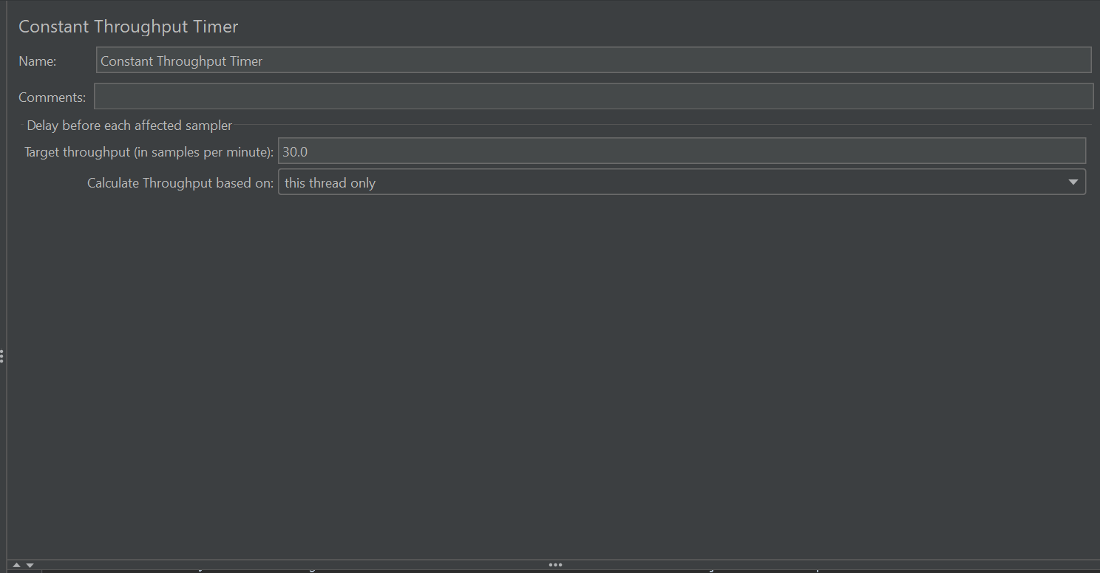

#### **🌐 D. Specialized Samplers**

| **Sampler** | **Used For** |
| --- | --- |
| **WebDriver Sampler** | Real browser-based testing (GUI validation, JS-heavy apps) |
| **Kafka Sampler** | Push/pull Kafka messages for performance and functional validation |
| **MongoDB Sampler** | Run queries on MongoDB as part of a test |

⚠️ *WebDriver Sampler is* ***resource intensive****, not recommended for load—use it for light functional workflows.*

#### **🔄 E. Useful Functions**

| **Function** | **Example** |
| --- | --- |
| __time() | Dynamic timestamp in requests |
| __RandomString(8,abcdef1234,) | Random value generator |
| __RandomInt(1,100) | Random number between 1 and 100 |

### **📥 3. Getting Started: Plugin Manager Setup**

#### **✅ Quick Summary**

1. Download from:<https://jmeter-plugins.org/wiki/PluginsManager/>
2. Place plugins-manager.jar in lib/ext
3. Restart JMeter
4. Use: Options → Plugins Manager

🔁 *The manager will handle* ***dependencies*** *automatically, unlike manual install.*

### **🧪 4. Mini Project Suggestion: Plugin-Enhanced Load Test**

**Scenario**: Test an e-commerce login + product page with 100 RPS over 10 minutes

🛠 **Setup**:

* Use Concurrency Thread Group (100 concurrent users)
* Add Throughput Shaping Timer (target 100 RPS)
* Add:  
  + Flexible File Writer
  + Response Times Over Time
  + Transaction Per Second

✅ Goal: Observe system behavior under consistent load, extract metrics into CSV or InfluxDB/Grafana for reporting.

### **👨‍💻 5. Writing Custom Plugin (Advanced)**

For **Java-savvy testers**, here's a summarized checklist:

| **Step** | **Task** |
| --- | --- |
| 1. | Setup Java IDE (IntelliJ or Eclipse) |
| 2. | Use Maven with JMeter core as dependency |
| 3. | Extend core classes: AbstractSampler, AbstractVisualizer |
| 4. | Override key methods like sample() |
| 5. | Build into JAR |
| 6. | Drop JAR into lib/ext and restart JMeter |

📘 Example use cases:

* Custom logic-based sampler (e.g., MQTT variant)
* Custom charting listener for business-specific KPI

### **🧠 Pro Tips**

* 📦 Always use **Plugins Manager** to avoid dependency hell.
* 🎨 Combine Composite Graph for side-by-side visualization of latency vs throughput.
* 📈 Export Flexible File Writer data to **Excel or Grafana**.
* 🧪 Don’t use WebDriver Sampler for load – use **Headless tools like Playwright, Puppeteer** outside JMeter for UI tests.
* 💾 Always version-control jmeter.properties and plugin versions used.